St. Mary’s Office of Youth Ministry

High School Youth Group

Ice Skating

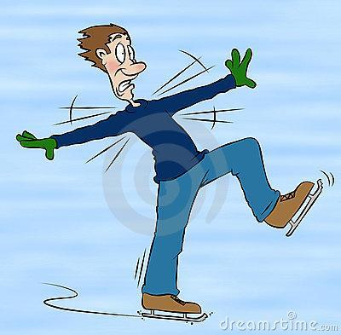
Saturday, December 13th
12-3pm
Cost :$15* + Cost of Lunch
Permission Slips & payment due by Friday, Dec 12th

Come out next Saturday for an afternoon of ice skating! We will meet up at the Parish Hall and walk over with the Our Lady of Lourdes Youth Group to go ice skating in Rockville Town Center! After skating we will grab a quick lunch and then walk back to St. Mary’s. Bring your friends!

Parental Release Form

Parental Release and Consent Form
*this form must be filled out and signed by a parent or guardian.

PLEASE RETURN THIS FORM TO THE OFFICE OF YOUTH MINISTRY or RECTORY:
No later than Saturday, December 13th, 2014

I, ________________________________________ the undersigned give my permission for my

son/daughter ___________________________________ to attend:

Ice Skating and Lunch in Rockville Town Center – Saturday December 13th – 12:00pm to about 3:00pm

In the event that I cannot be reached, I hereby give permission for my child to be evaluated, diagnosed, treated, and/or medicated in accordance with standard medical practice by medical personnel. I relieve St. Mary’s Parish and staff, the Archdiocese of Washington, D.C., and all chaperones from all responsibility and/or consequences that might arise as the result of this treatment. Further, I agree to accept all financial responsibility resulting from said treatment. I will not hold St. Mary’s Parish and staff, the Archdiocese of Washington, D.C., and any chaperones responsible in the event of an injury or accident. I recognize that immediate expulsion from the trip may occur if my child does not comply with the rules and regulations set forth by the Parish and the Archdiocese of Washington, D.C. I understand that this expulsion is subject to the judgment of the Youth Minister and chaperones present and I will not hold them responsible for any consequence. I also understand that I am financially responsible for any cost that this expulsion may incur. I have read the rules and regulations together with my child, as outlined in the Code of Student Conduct. I have made sure that he/she fully understands them and the consequences for not complying. I have witnessed their signature on the Code of Student Behavior.

Address:______________________________________ City: ___________________ State:_________ Zip:__________
Phone:____________________________ Cell:________________________________________
Work:_______________________________________ Email______________________________________________
Emergency Contact Name: _______________________________________________________________________
Emergency Contact Phone:________________________ Cell (Emergency only):____________________________
2nd Emergency Contact Name:____________________________________________________________________
2nd Emergency Contact Phone:__________________________ Cell ( Emergency only):_______________________
Parent/Guardian Signature _______________________________________________________________________
ALL NON-REGISTERED MEMBERS OF YOUTH GROUP MUST ALSO COMPLETE A MEDICAL RELEASE FORM AND CODE OF BEHAVIOR FORM!!! Space are limited and on first come first serve basis, so turn in your form as soon as possible please!!

